2021-2022

Confirmation Preparation
GUIDEBOOK
FOR CANDIDATES & THEIR PARENTS

NAME __________________________________________

SAINT PAUL CATHOLIC CHURCH
9240 DAMASCUS ROAD
DAMASCUS, MD 20872
301-253-2027
www.StPaulMiddleSchool.weebly.com

TABLE of CONTENTS

Introduction …………….……………………………..……...2
Participation in Mass ………….……………………..………4
Participation in Classes …………………………….………..5
Kingdom Work ……………..………………………..……….6
Pilgrimage Trip ……………………………………….……...7
Letter of Intent ……………..…………………..……………..8
Sponsor ……..………………………………………….........10
Confirmation Saint ………….……………………………....12
Letter to the Bishop …………………..……………………..14
NET Retreat …......…………………….…………………….16
Clergy Interview/Exit Interview..…..……………………..16
Confirmation Rehearsal ……………..……………………..17
Confirmation Mass ……………………..…………………...17
Parent Pages …………………………..……………………..18
All Items to Turn In ……………………..…………………..20
Tracking Sheet ………………………….….………………..23

Important Note:
All dates, times, and details for events listed in this guidebook were accurate at the time of print (August 2021.) Due to variables within the parish schedule, liturgical calendar, weather, or unforeseen circumstances, there is a possibility some of these details may change. The most accurate and updated information can be found on our website www.stpauldamascus.org or www.stpaulmiddleschool.weebly.com. Pay close attention to all email communications sent throughout the year. Communications will come through Flocknote.
Introduction

Preparing for a sacramental encounter with our savior, Jesus Christ, is an opportunity to learn more about your Catholic faith and what it means to be a disciple of Jesus Christ.

As a participant in our parish Confirmation II program, this will be a focused and intense year of preparation as you continue your journey towards the sacrament of Confirmation. As you will see, Confirmation preparation involves and leads you to learning, sharing, serving, fellowship, and spiritual growth! Your parish faith community and the Religious Education staff look forward to sharing this journey of faith with you.

What is Confirmation?
Confirmation is one of the three Sacraments of Initiation. Baptism is the first step of initiation into the life of the Church; Confirmation is the completion of the Baptismal commitment. According to the Catechism of the Catholic Church, “The reception of the sacrament of Confirmation is necessary for the completion of baptismal grace” (no. 1285). There are two primary effects from the sacrament of Confirmation: strengthening of one’s bond with the Church, and reception of the gifts of the Holy Spirit.

This guidebook gives an overview of the invitation into deeper relationship with Christ, as the youth of Saint Paul Catholic Church enroll in Confirmation preparation as well as how parents and sponsors can walk with the candidate in faith. Preparation for Confirmation invites a renewal of faith for the whole family, and it is our hope that your family will grow in God’s grace throughout the year!

Who May Be Confirmed?
Requirements for Confirmation – the candidate must:

- Have received the sacrament of Baptism and have not yet been confirmed
- Be a person who has the use of reason and is able to renew their baptismal promises.
- Have been adequately and suitably instructed in the Roman Catholic faith. This is usually accomplished through ongoing participation in a Roman Catholic parish or school-sponsored religious education program.
- Demonstrate knowledge and understanding of the obligations of a practicing member of the Catholic Church.
- Have a sincere desire (properly disposed) to receive the sacrament as well as an appreciation of the sacramental life of the Church.
- Sincerely work to strengthen their relationship with Christ.
- Formally identify themselves as a candidate seeking Confirmation – this takes shape as a letter to the pastor requesting to be enrolled as a candidate.

Forming Disciples for the New Evangelization

Archdiocesan Religion Curriculum

The Archdiocese of Washington has provided all parishes with a Religious Curriculum Guide, Forming Disciples for the New Evangelization. This document clearly states what participants in parish religious education programs should be able to know, understand and do at each grade level.

The primary aim of the standards is to strengthen the teaching of the faith. It is directed toward the whole local church. These guidelines focus on the need for mutual collaboration, communication and consultation. They strive to clarify the roles, responsibilities and mutual accountabilities needed by pastors, parents, catechetical leaders and all who assist in efforts to put adults, youth and children into communion and intimacy with Jesus Christ through life-long catechesis in and through the Catholic Church. You may access your grade-specific standards at
https://adw.org/learning-the-faith/catechetical-resources/forming-disciples/

The witness of Christian life given by parents in the family comes to the children with tenderness and parental respect…It is deepened all the more when parents comment on the more methodical catechesis which their children later receive in the Christian community and help them to appropriate it. (General Directory for Catechesis, no. 226 and CT, no. 68)

An invitation to grow

The following pages explain the Saint Paul parish Confirmation preparation program in detail. Candidates are asked to make every effort to participate fully in each expected component of this program. The components are not laid out as a checklist, but rather as opportunities for enriching the lived faith experience for each candidate.

We must know who we are in Christ before we can witness to His love in the world. In Confirmation, we receive the gift of the Holy Spirit to fulfill the Gospel mission: “Go, therefore, and make disciples of all nations, baptizing them in the name of the Father, and of the Son and of the Holy Spirit, teaching them to observe all that I have commanded you.” (Mt. 28:19-20a) This is the call of every Catholic Christian. As you journey towards the sacrament of Confirmation and the completion of initiation into the Church, it is important to remember that this must be a free choice on the part of the candidate.

Participation in Mass

Participate in Mass every week and on holy days of obligation

So they said to him, “Sir, give us this bread always.” Jesus said to them, “I am the bread of life; whoever comes to me will never hunger, and who ever believes in me will not thirst.” John 6:34-35

When we come to Mass, we do not come for the “experience.” For amazing sermons or stellar worship music. We come to Mass to be strengthened and nourished. Mass is not optional for a follower of Christ- we need to regularly encounter our Creator and our Lord. This is why the Church is clear that there is an obligation to go to Mass on a weekly basis, and on certain holy days.

When we worship as a community, we build up the Body of Christ because we are ‘being the Body of Christ’. The following excerpts from the Catechism of the Catholic Church (CCC) are offered to help the candidate deepen his/her understanding of why the Eucharistic celebration is the source and summit of the Christian life. In fact, intentionally keeping oneself away from the Mass may be a situation of grave sin.

“Take this and eat it, all of you”; communion (CCC 1384-1387)

1384 The Lord addresses an invitation to us, urging us to receive him in the sacrament of the Eucharist: "Truly, I say to you, unless you eat the flesh of the Son of man and drink his blood, you have no life in you." (Jn 6:53)
1385 To respond to this invitation we must prepare ourselves for so great and so holy a moment. St. Paul urges us to examine our conscience: "Whoever, therefore, eats the bread or drinks the cup of the Lord in an unworthy manner will be guilty of profaning the body and blood of the Lord. Let a man examine himself, and so eat of the bread and drink of the cup. For anyone who eats and drinks without discerning the body eats and drinks judgment upon himself." (1 Cor. 11:27-29) Anyone conscious of a grave sin must receive the sacrament of Reconciliation before coming to communion.

The Sunday obligation (CCC 2180-2182)

2180 The precept of the Church specifies the law of the Lord more precisely: "On Sundays and other holy days of obligation the faithful are bound to participate in the Mass." …
2181 The Sunday Eucharist is the foundation and confirmation of all Christian practice. For this reason the faithful are obliged to participate in the Eucharist on days of obligation, unless excused for a serious reason (for example, illness, the care of infants) or dispensed by their own pastor. Those who deliberately fail in this obligation commit a grave sin.
2182 Participation in the communal celebration of the Sunday Eucharist is a testimony of belonging and of being faithful to Christ and to his Church. The faithful give witness by this to their communion in faith and charity. Together they testify to God's holiness and their hope of salvation. They strengthen one another under the guidance of the Holy Spirit.
Participation in Classes

Actively participate in Confirmation classes, complete at-home assignments, as well as any make-up work for activities and classes you were unable to attend.

Formation is a critical component of growth in faith. Saint Paul tells us in his letter to the Romans, “Faith comes from what is heard” (Rom. 10:17a). It follows to reason that the classroom faith formation experience will assist in preparing the candidates for reception of the sacrament. When a class is missed, the candidate loses time for fellowship and prayer as well as the material covered that day. As your child prepares for Confirmation, please make these gatherings a priority and therefore make a sincere effort to adjust your other obligations accordingly.

Details
Out of respect for our volunteer catechists, and for peers, we ask that students be prepared for the classes, including arriving on time and staying for the entire session. This also includes completing any assigned readings or homework. Contact your catechist immediately if critical circumstances will not allow you to attend a class. The material covered in class is woven together to help the candidate ponder/ask/get answers to questions about the faith, to grow the candidate’s understanding of the faith and to enter more deeply into relationship with Christ. To give students the best opportunity to be fully prepared to say YES to Confirmation, any missed classes may result in reviewing the material at home with a parent or the candidate’s sponsor.

Excessive absenteeism (missing more than two classes) can affect the candidate’s ability to enter fully into this important period of preparation.

There may be situations (i.e. excessive absenteeism; lack of desire to be confirmed) where, at the Pastor’s discretion, it might be deemed prudent to temporarily delay the confirming of a candidate until the candidate is deemed ready. As the pastor must attest to the Bishop that the candidates are ready, all final decisions regarding a candidate’s readiness are evaluated by the pastor. If the candidate is facing an obstacle to full readiness for Confirmation, Father Filardi or Megan McQuin would be happy to meet with the candidate and his/her parents to determine the best course of action.

What to Do if You Miss a Class

- Parents, if you know ahead of time that your candidate cannot make it to a class date, contact your catechist by email ahead of time to let him/her know.
- If you realize after the fact that your candidate missed class, please also contact your catechist as soon as possible to touch base.
- The catechist should provide parents with the number of the lesson and instructions for how to access the lesson videos online. Parents, to make up a lesson you will sit with your candidate to work through the lesson book, watch the videos, and discuss the content.
Kingdom Work

Participate in opportunities to do the work of building up the Kingdom of God in the parish environment.

As the old familiar song goes, “And they will know that we are Christians by our love.” A part of our calling is to engage in service to others. Part of discipleship is the calling to build up the Kingdom of God on earth. Scripture clearly illustrates that we are to love our neighbor and stand up for justice and peace. Serving others is something we do because we recognize the presence of Jesus in all persons and in all of God’s creation.

You shall love the Lord, your God, with all your heart, with all your being, with all your strength, and with all your mind, and your neighbor as yourself. He replied to him, ‘You have answered correctly; do this and you will live.’” -- (Luke 10: 27-28)

Jesus Christ is ushering in the Kingdom of God here on Earth, right now, and we each have an important stake in this work. For all members of Saint Paul parish, there are many opportunities to get involved serving the community through parish involvement. This is not something just for our Confirmation students. All practicing Catholics should be engaged in parish life and offer their time and talents to God to be used for helping build up the church and those she serves.
Details
In the Fall, candidates will receive a list of options to choose from for their Kingdom Work. Each option will be a ministry within Saint Paul Parish through which the candidate will be mentored and become a contributing member. Each ministry will clearly outline how the candidates who sign up will be expected to participate. Parents will sign their candidate up for a ministry on the list and then attend an initial meeting with their candidate to kick off their involvement.

This is not equivalent to SSL hours. We are not asking the candidates to document a certain number of hours to “complete the requirement.” We are asking that each candidate become actively involved in a parish ministry and feel the true impact of allowing Christ’s Kingdom to be present to our parish through his/her time and talents.

Specifics for each ministry will be sent by email in the Fall, but we anticipate the following ministries to be working with us to mentor teens for their Kingdom Work.

- Fellowship Ministry
- Religious Education
- Knights of Columbus
  - Catholic Daughters
  - Drama Ministry
  - Music Ministry

I can offer my time and talents to God through…
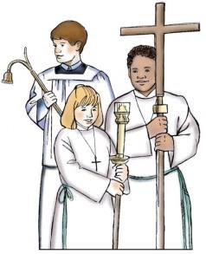  Being an  Altar server | 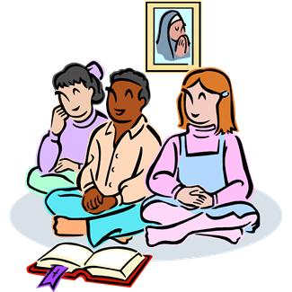  Helping out  in a Religious  Ed class
Join our pro-life  ministry | 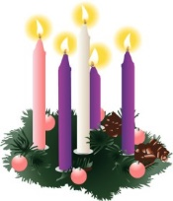  Decorating the church for each  liturgical season
Helping to maintain our parish garden | Crocheting  hats for babies  in need
Act or assist in  seasonal drama  productions | 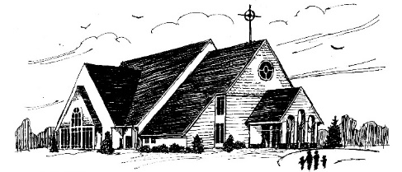  Here I am, Lord.  Send me.  -Isaiah 6:8
Pilgrimage Trip

Attend off-site Pilgrimage Trip

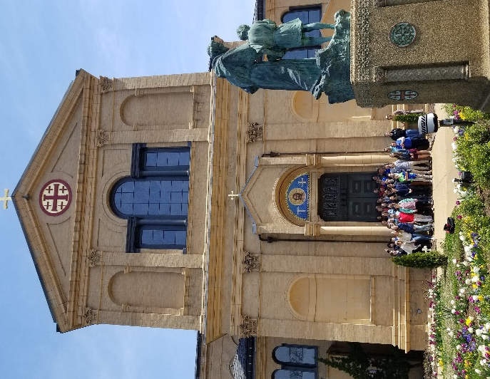
We may not be able to travel to the Holy Land, but we can still take time out of our busy lives to delve more deeply into our Catholic faith by visiting holy sites and spend some time in prayer. This is an opportunity to learn more about the breadth and depth of our Catholic identity as well as enhance the spiritual growth of our youth.

Details
Our Pilgrimage is an off-site field trip. This year we will be going to the Shrine of Saint Anthony in Ellicott City on October 2, 2021 from 10am – 2pm. There will be time to learn about the history of the Shrine and the Franciscan order, time for Confession, prayer and Mass, and we will enjoy lunch as a community. Parents will be asked to transport their child to/from the Shrine, and are encouraged to stay.

Letter of Intent

Type a letter of intent to Monsignor Filardi. Print it, sign it, and turn it in by October 1.

The letter of intent allows the candidate to formally inform the Church, by way of the pastor, that he/she would like to enter into a period of discernment for the sacrament of Confirmation. In this letter, the candidate also expresses willingness to commit to the period of preparation. Upon receiving this letter from a candidate we can officially enroll him or her for the sacrament. Please use the following as a guide for the letter:

Details
Your Letter of Intent should be addressed to the pastor, Msgr. Edward Filardi. You can find an outline of what to include in your letter on the next page.

1. Type your Letter 2. Print it out 3. Sign your Letter

This letter must be turned in as a hard copy. Before turning it in, please place it in an envelope labeled “LETTER OF INTENT c/o: Religious Ed Staff” You may drop it off at the parish office, drop it in the collection basket (please be sure to label the envelope as directed above) at weekend Mass, or hand it in at one of your Confirmation classes.

Choose a Scripture Verse
Isaiah 11:2 Isaiah 61:1
Matthew 3:13-17 John 1: 33-34
John 14: 15-31 John 16: 5-15
Acts 2: 1-4 Acts 8: 14-17
Galatians 5: 22-23 2 Corinthians 1:21-22
Each candidate should choose one or more Scripture verse(s) to reflect on during his or her Confirmation preparation. You will reference the verse you choose in the letter of intent (directions above.) Possible options for scripture verses are in the box to the left.

CONTINUED ON NEXT PAGE…
This letter should be turned in before
October 1.

Reminder:
Must be turned in
as a hard copy.

Outline to follow for your Letter of Intent

Greeting
Begin with your greeting: Dear Father Filardi,

Beginning
Introduce yourself and share some information about yourself, such as your family, your interests and hobbies, and a little about your background.

Middle
State that you would like to be enrolled as a candidate for the Sacrament of Confirmation and explain (in one or two paragraphs) why you want to be confirmed. It may help you to think about
- the ways in which this sacrament will strengthen your relationship with Jesus,
- the role of faith in your life
- what it means to you to be a part of our parish community and/or
- how the Holy Spirit empowered the apostles to be witnesses for Jesus (read and reflect on the Acts of the Apostles.)

End
To conclude your letter you will need to select a quotation from Scripture (chosen from the list on the previous page) which will serve as your inspiration during your preparation for Confirmation. This can be one verse or a few verses. Include an explanation as to why you chose this passage.

Signature
To end your letter write “Sincerely,” then leave a space for your handwritten signature, and finally, type your first and last name. Sign the letter in pen.
Choosing a Sponsor
Choose someone who meets the criteria with whom you will meet regularly as part of your preparation.
Give your sponsor the Sponsor Form to fill out and turn in. Should be returned by your sponsor by
November 15.

Details
The confirmation sponsor must be a baptized, confirmed, practicing Roman Catholic and should be a person who can serve as a strong role-model of an active, Spirit-filled Catholic.

What does the sponsor do?
This person is a representative of the whole Church into which the candidate is being confirmed, serves as a witness for the Church and companions the candidate on his/her faith journey. Your sponsor will bring you forward to receive the sacrament, present you to the Bishop for anointing, and will later help you to fulfill your baptismal promises faithfully under the influence of the Holy Spirit whom you have received.

Thus, it is recommended that the sponsor be able to meet regularly with the candidate, spend time building a bond with the teen, help him/her prepare for the sacrament through prayer, study, service and discussion and be in physical attendance at the rehearsal and the Confirmation liturgy.

What are the qualifications of a sponsor?
Pastors are charged with the responsibility of seeing that the sponsors of our candidates are of adequate maturity and Catholic formation to take on this responsibility.

A sponsor must be:
- of sufficient maturity to fulfill this role (at least 16 years old)
- a practicing Roman Catholic who has been baptized, confirmed and received the sacrament of First Holy Communion. He/She should participate in the celebration of the Eucharist each week
- fulfilling their own baptismal promises by living the Christian life of faith and morals, guided by the teachings of the Catholic Church
- be in good standing with the church and not prohibited by [church] law from exercising the role of sponsor (ex. irregular marriage)
- not be a parent of the Confirmation candidate

The form your sponsor will fill out will ask him/her to review and check off these qualifications.
Things to
TIP #2
Your sponsor should be someone who, through his/her example, shows you what it means to be Catholic.
think about
TIP #1
Your sponsor should be someone that you trust and feel comfortable turning to for help, advice and guidance, especially in regard to your spiritual life.
before you ask
someone to be
your sponsor:
TIP #4

TIP #3
Your sponsor should be willing and able to take an active role in your preparation for Confirmation.
Your sponsor is your choice. Think of someone that you respect and who actively lives out the beliefs of our Catholic faith—someone with a relationship with Christ that you would hope to learn from.
TIP #5
It is highly recommended (though not required) that the sponsor be a baptismal godparent of the confirmation candidate. This most fully expresses the integral connection between Baptism and Confirmation.

TIP #6
After you receive the Sacrament of Confirmation your relationship with your sponsor does not end! You both are called to lead each other closer to God, to continue to grow in knowledge of your faith, and to challenge one another to lead lives of holiness and service.

TIP #7
PRAY! Spend some time asking God for
guidance on who to choose as your sponsor.

Frequently Asked Questions
- Can I have more than one sponsor? No, there is one sponsor for each person confirmed.
- What if my sponsor cannot make it to Confirmation? Attendance by proxy is allowed in certain situations, such as the sponsor living out-of-town and being unable to travel to the celebration. Requests for proxy should be directed to the parish Director of Religious Education.

Once you have chosen your Sponsor
Once you know who you would like to have as your Confirmation Sponsor, find a personal time to ask him or her. If he/she says yes, be sure to give them:
- The Sponsor Form (found in this guidebook
and on our website, due November 15.)
- The DATE and TIME for Confirmation (when we
know that information)
Confirmation Saint

Choose a Confirmation saint who will become your heavenly patron and whose name will be used in your Confirmation. Complete the Saint Form handout and turn it in by the end of January, 2021.

Just as your sponsor will stand by your side as a witness at your Confirmation, your Confirmation saint will be present as your heavenly sponsor and witness and will intercede for you for all of eternity. You will be addressed by your chosen Saint’s name when you are confirmed.

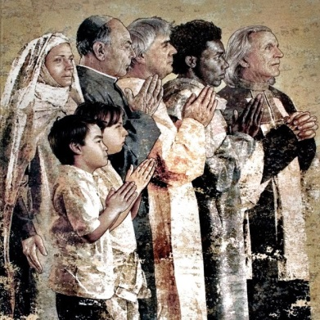
In both the Old and New Testament, when God had a new mission for someone, He often gave them a new name. Even without a new name, your name has always told others who you are. God calls on each of us to fulfill a special mission. It may be witnessing to non-believers about Jesus Christ, helping the poor, being a peacemaker, entering a religious vocation, or one of many other callings. Confirmation may be the continuation of a mission direction you began at Baptism or the beginning of a new mission. Our missions may be expressed in different ways; therefore there are two options when deciding on a Confirmation name:

First Option - Because Confirmation is the strengthening of the work that God began in your life at your Baptism, it is recommended that you give first preference to using your Baptismal name for Confirmation. This shows the integral link between Baptism and Confirmation (note: this applies only if your Baptismal name was a Saint’s name.)

Second Option – Perhaps you see Confirmation as the beginning of a new phase of mission for you and a fresh beginning in your faith journey. Then you may choose a new name for Confirmation. Your Confirmation name should be that of a saint you admire or the saint name of someone you know and look up to as a Christian role-model.

Frequently Asked Questions
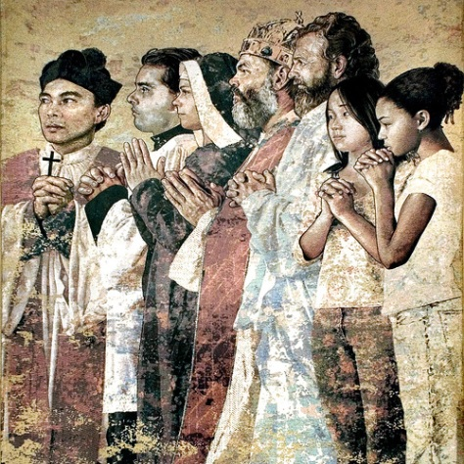
- What if I can’t find the canonization date for the saint I’ve chosen? The saint you choose must be a Canonized Saint in the Roman Rite. The saint form asks for a date of canonization. Some saints will have “pre-congregation” listed instead of a canonization date. This means that the saint was recognized as a Catholic saint before the Church developed her current model for canonization. In this case, write “pre-congregation” as the canonization date. If you cannot find this date for your saint please contact us for guidance.
- Do I have to choose a saint that is the same gender as I am? No, you can choose a male saint or a female saint regardless of your own gender.
Helpful Hints
First…PRAY! Just as you should pray about any decision, ask the Holy Spirit to guide you as you choose a saint. Where should I begin to choose a Confirmation name?

Remember,
your Confirmation name is the
- name of a saint
and should
- reflect your closer
identification as a
member of the Catholic Christian community.

So, you can choose…
… to use your given
baptismal name if it is the name of a saint. (Church recommends)
… a new name.
Whose holiness would you like to strive to emulate?

The name you select can be a saint you have researched and feel a connection to, based on his/her patronage, qualities, and/or life story.
The name you select can be associated with someone in your life, your parish, or your community whom you respect and admire.

Research the saints online! Visit our program website to find links to articles and sites that can help. www.stpaulmiddle
school.weebly.com

There are a variety of books depicting the lives of the saints and a book is a great place to start! Check the library or borrow one of ours!

Some candidates select the name of their Confirmation sponsor, or the saint their sponsor chose when he/she was confirmed.
Some Confirmation candidates select a name from a parent or grandparent, honoring them for their example of love and holiness.

Once you have chosen your Confirmation Saint
Complete the Saint Form. You may drop it off at the parish office, drop it in the collection basket (please be sure to label the envelope Confirmation Saint Form c/o Religious Education staff) at weekend Mass, or hand it in at one of your Confirmation classes.
- The saint form must be turned in by the end of January, 2021.
- Spend time in prayer with your Saint. Your confirmation saint is your heavenly sponsor; so just like your earthly sponsor, your saint should play a role in your preparation. Ask him/her for guidance and to intercede for you. You may also seek out more information about your saint, like an autobiography or a specific prayer associated with him/her.
Letter to the Bishop

Write a letter to the Bishop, print it, sign it, and turn it in by the beginning of August.

It has been customary for the Bishop to receive a letter from each candidate; a personal letter to him requesting Confirmation.

Details
This letter is not just getting stuffed in a drawer somewhere—you are writing a letter that will be mailed to the Bishop who will preside over your Confirmation. The letter must be typed and signed by you. The formality and importance with which you present this letter should show the highest respect for the office of the Bishop.

Parents, ways you can help do this are:
- Discuss the prompt and expectations with your candidate before they begin writing.
- Proofread your candidate’s letter to be sure it is respectfully formal and there are no typos.
- Consider using stationary paper of some kind rather than regular printer paper to reflect the formality of addressing the Bishop.

1. Type your Letter 2. Print it out 3. Sign your Letter

This letter must be turned in as a hard copy. Before turning it in, please place it in an envelope labeled “LETTER TO BISHOP c/o: Saint Paul Religious Ed Staff” You may drop it off at the parish office, hand it in to the welcome desk at a weekend Mass, or hand it in at one of your Confirmation classes.

[What do we mean by “cc:” at the bottom of the outline? By “copying” Fr. Filardi and Megan McQuin, you are indicating that you understand all of these people may review your letter. You do not need to submit more than one physical copy of your letter.]

CONTINUED ON NEXT PAGE…
Confirmation Retreat
This letter should be turned in by August 1.

Outline to follow for your Letter to the Bishop

Heading
In the top left corner of your page put:
Most Reverend [Bishop’s First and Last Name]
Archdiocese of Washington

Greeting
Begin with the greeting: Dear Most Reverend [Bishop’s First and Last Name],

Body
Write to the Bishop with seriousness and respect---but also write from your heart. The body of your letter should clearly express the following:
- that receiving the Sacrament of Confirmation is your desire
- the ways that you have prepared for the sacrament
- the scripture passage you chose in your Letter of Intent and how your understanding of this passage has grown in the last year
- who your confirmation saint is and why you are choosing him/her

Signature
To end your letter write “Sincerely,” then leave a space for your handwritten signature. Finally, type the following:

[Your full name]
Saint Paul Parish

cc: Monsignor Edward Filardi
Megan McQuin

Reminder:
Must be turned in
as a hard copy.

Attend the parish-sponsored Confirmation retreat
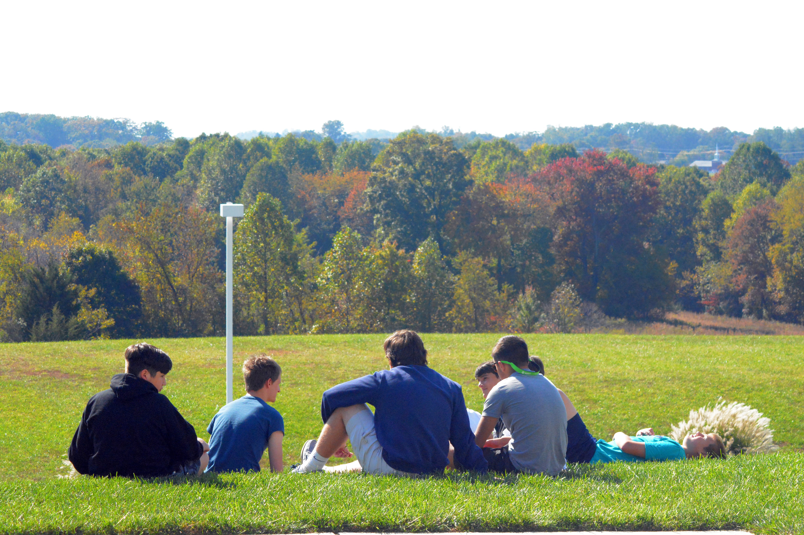
Retreats provide a unique opportunity for the candidates to spend an extended time in discernment, reflect on the gifts of the Spirit and reflect on their relationship with God and their faith life.

Details
More information regarding the Confirmation retreat will be forthcoming, but it will extend through a full day. This is the only Confirmation Retreat offered by Saint Paul parish. It is expected that all candidates make all effort to attend this retreat with his/her peers. If you have a serious conflict, contact our Religious Ed Staff as soon as possible. (You will be expected to make this up by attending a retreat at another parish.)

Clergy Interview/Exit interview

Participate in an interview with the Confirmation Coordinator (exit) and our Pastor or one of our Deacons. (August 2022)

The pastor will have to attest to the Bishop that the candidates are ready to receive the Sacrament of Confirmation. The Bishop has the right to publicly examine the Confirmation candidates during the liturgy. The purpose of this meeting with Father Filardi or one of our parish deacons is twofold:

- for the clergy to have an opportunity to determine the readiness of the candidates and
- to prepare candidates to respond to the Bishop’s questions posed to them during the liturgy
*The exit interview is an addition and will occur alongside the clergy interview. You will meet with the Confirmation coordinator to share your experience of the Confirmation process, and offer feedback.
Details
In the summer of 2022, parents will receive an email with a list of the dates/times of our clergy interviews. You will select the date/time that works for you and sign up to attend it. Clergy interviews are held individually or in groups, at the pastor’s discretion. Parents are welcome to attend, but not required.

Confirmation Rehearsal

All candidates are required to attend Confirmation Rehearsal with their sponsor.

Date To Be Determined

We will rehearse the logistics of Confirmation as well as be sure we have all final questions answered and information collected. It is essential that every single candidate is present so we can be sure when the Bishop is celebrating Mass with us things run smoothly and we are all able to focus on the sacrament itself. Fr. Filardi holds the mandatory status of this rehearsal with strict regard. To be clear any exceptions to attending rehearsal must be cleared by the pastor.

Candidates and their SPONSORS must be in attendance for this rehearsal. If a sponsor cannot attend, a parent may stand in as a proxy FOR REHEARSAL.

Confirmation Mass

Participate in the liturgy and Rite of Confirmation.

Date To Be Determined

Details
You will receive more details, including arrival time instructions and an FAQ sheet, as the date draws near.

“All-powerful God, Father of our Lord Jesus Christ, by water and the Holy Spirit you freed your sons and daughters from sin and gave them new life. Send your Holy Spirit upon them to be their Helper and Guide. Give them the spirit of wisdom and understanding, the spirit of right judgment and courage, the spirit of knowledge and reverence. Fill them with the spirit of wonder and awe in your presence.”
Rite of Confirmation 25
What about Parents?

“As the primary educators of their children: parents are to be intimately involved in the catechesis for Confirmation. This will help them renew and strengthen their own faith, besides enabling them to set a better example for their children.”(NCD, no. 119)

This year, we would like to invite parents into a deeper experience of journeying with your child through the Confirmation process. The Confirmation coordinator will be providing additional resources to parents as they walk with their child towards this sacrament.

Roles and Responsibilities
All parents are expected to:
- Ensure that their candidate participates in Mass regularly and the sacrament of reconciliation. Ideally, this will be a family experience.
- Pray for your child’s spiritual growth every day.
- Be actively involved in the Confirmation preparation of the candidate.
- Engage in discussions about the material being studied, including sharing your understanding and perspective.
- Support and require completion of assignments, activities and expectations.
- Faithfully bring your teen (and, when necessary, yourself) to classes, retreats, meetings and special events arriving on time and participating until the event is complete.
- Volunteer for retreats, service, meetings, classes, spiritual events and/or social events.
- Model responsible and active church membership to your child.

Spiritual Leaders of the Family

What influences the Faith Life of Your Child?
Your child’s future faith life will be directly affected by the personal faith of you, as parents, as well as the religious experiences and practices of both the family and the child. Now is a good time to stop and refocus. Ask yourself this question—

Would I be comfortable with how my child would describe
the spiritual life of our family? My own spiritual life?

Consider some findings from recent PEW FORUM surveys on religion:
- Religious commitment as a child and teenager may be related to the propensity to change religion
- Among Americans ages 18-29, one-in-four say they are not currently affiliated with any particular religion.
CONTINUED ON NEXT PAGE…

- Former Catholics who are now unaffiliated are much less likely than lifelong Catholics to have attended Mass regularly or to have had very strong faith as teenagers.
- Only 39% of self-identified Catholics attend religious services at least once a week.
- …among both former Protestants and former Catholics who are now unaffiliated, more than seven-in-ten say they just gradually drifted away from their childhood religion.

Confirmation can be a key event to prevent the “drift.” As spiritual leaders of the family, you are invited to take a moment to reflect on how this confirmation period may be a time for the entire family to refocus on Jesus Christ.

Tools for Faith as Family

Enter into this grace-filled moment with your child by:

- Beginning/renewing a daily prayer practice (www.sacredspace.ie.)
- Reflecting on the Sunday readings before Mass (www.usccb.org)
- Recommit to actively and regularly participating in Sunday Eucharist.
- Prepare for your own Confirmation (if you have not yet been confirmed) Adults can be confirmed too! What are you waiting for?
- Learn more about Catholic belief (can you explain the faith that you profess to your friends or family?) Don’t carry around an 8th grade level of knowledge of our faith. Jesus wants to give you more!
  - www.ewtn.com
  - www.usccb.org/catechism
  - www.bustedhalo.com (online magazine for spiritual seekers)
  - Go to www.formed.org (parish access code is R8Z6MZ)
  - Call our Religious Education Director to find out about adult faith formation programs at our parish.
  - Join RCIA inquiry (for non-Catholics who wish to explore the Catholic faith)
- Nurture your marriage
  - Pray together
  - www.foryourmarriage.org (resources)
  - Renew your nuptial vows (or have your marriage blessed by the Church)

The Bottom Line

The Holy Spirit is waiting to rain down upon the entire family, along with your Confirmation candidate! Will you seize this grace-filled moment?!

Please know that our Religious Education staff looks forward to assisting you in this journey. We are praying for you!

Review of Forms to be Turned In

Candidate Enrollment Form
Expectation: Turn in a Candidate Enrollment Form by
October 1.

Receiving this form gives us the data we need to record your confirmation in the parish sacramental records.
DUE
OCT

Details
The form can be found as an electronic copy on our website.

Letter of Intent
DUE
OCT
Type a letter of intent to Monsignor Filardi, print it, sign it, and turn it in by October 1.
Details
All information can be found on pages 8-9 of this guidebook.

Pilgrimage Permission Slip
Expectation: Turn in permission slip and payment to attend
trip. All candidates are expected to attend.

Why is this important?
Read about our pilgrimage trip page 7 of this guidebook.
DUE
TBD

Details
The form is not included in this guidebook as the trip details are still being determined. Stay tuned by email for an update as we get closer to the date of the trip.

Sponsor Form
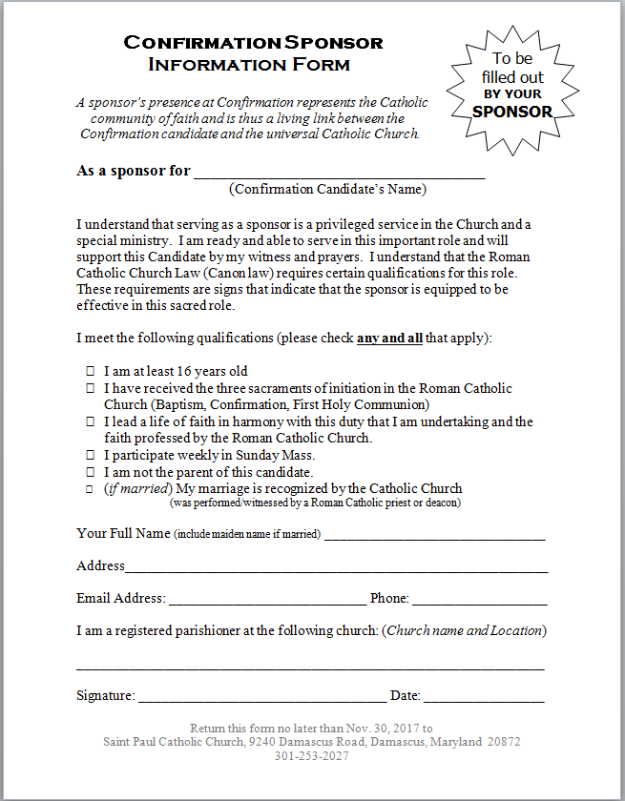
Expectation: Ask your sponsor to complete and send in the
Sponsor form by October 1.

Why is this important?
By filling out and signing this form, your sponsor is indicating to us that he/she meets all qualifications necessary and allows us to have their information on file for your sacramental records.
DUE
OCT

Details
The form can be found as an electronic copy on our website.

Saint Form
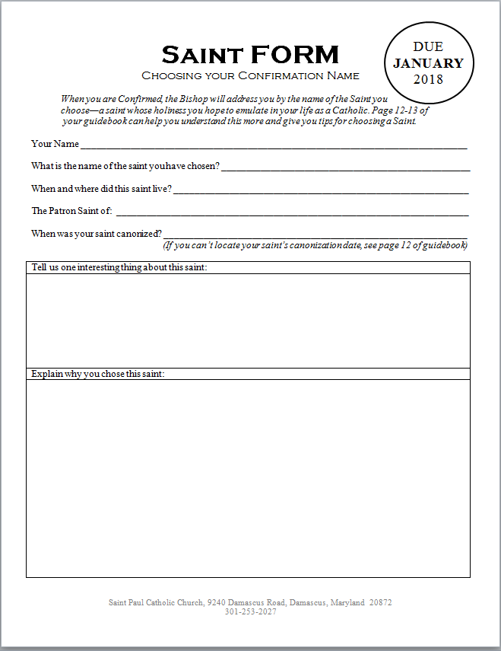
Expectation: Choose a saint and turn in the Saint Form by the
end of January, 2021.

Why is this important?
Receiving this form gives us the data we need to record your confirmation in the parish sacramental records.
DUE
JAN

Details
The form can be found as an electronic copy on our website.

Letter to the Bishop
DUE
AUG
Expectation: Type your letter to the Bishop, print it, sign it, and submit in August.
Details
All information can be found on pages 14-15 of this guidebook.

 | Quick Reference
□ | Participation in Mass Page 4 | ALL YEAR
 | Participate in Mass every week and on holy days of obligation
□ | Participation in Classes Page 5 | ALL YEAR
 | Actively participate in Confirmation classes, complete at-home assignments, as well as any make-up work for activities and classes you were unable to attend.
□ | Kingdom Work Page 6 | ALL YEAR
 | Participate in a year-long mentoring project with one of our selected parish ministries. (Sign-ups occurring in the Fall, sent by email.)
□ | Candidate Enrollment Form Page 20 | DUE OCT
 | Turn in a Candidate Enrollment Form by November 15.
□ | Letter of Intent Page 8 | DUE OCT
 | Type a letter of intent to Fr. Filardi. Print, sign, and turn it in by November 15.
□ | Pilgrimage Trip Page 7 | OCT 2
 | Attend the off-site Pilgrimage trip. Turn in form and payment.
□ | Sponsor Page 10 | DUE OCT
 | Choose a qualified sponsor with whom you will meet regularly. Give your sponsor the sponsor form to fill out and turn in by November 15
□ | Confirmation Saint Page 12 | DUE JAN
 | Choose a Saint who will become your heavenly Patron, whose name will be used in your Confirmation. Complete and turn in the Saint Form by the end of January 2021.
□ | Confirmation Retreat Page 16 | TBD
 | Attend the Confirmation Retreat (TBD)
□ | Letter to the Bishop Page 14 | DUE AUG
 | Write a letter to the Bishop. Print, sign, and turn it in by the end of May 2021
□ | Clergy Interview Page 16 | SUMMER 2021
 | Participate in an interview with Pastor or Deacons. (August 2021)
□ | Confirmation Rehearsal Page 17 | TBD
 | All candidates are required to attend rehearsal.
 | CONFIRMATION LITURGY Page 17 | TBD

NOTES

From The Rites of the Catholic Church, as revised by the Second Vatican Ecumenical Council, vol. 1, p. 480.
U.S. Religious Landscape Survey. The Pew Forum on Religion and Public Life. Accessed on 7/11/18. http://www.pewforum.org/religious-landscape-study/
Ibid. http://pewforum.org/docs/?DocID=409
Ibid. http://www.pewforum.org/religious-landscape-study/religious-tradition/catholic/
Ibid. http://www.pewforum.org/2015/05/12/chapter-2-religious-switching-and-intermarriage/

